1. **Basic information**
2. **Partners Group**

* Founded in 1996 and headquartered in Zug, Switzerland
* AUM of USD 74 billion: 51% of capital invested in Europe (AUM of EUR 40 billion), 36% in North America and 13% in Asia Pacific
* Serving over 1,000 institutional investors worldwide: Public pension funds, insurance companies, private pension funds, banks and distribution partners (see diagram below)

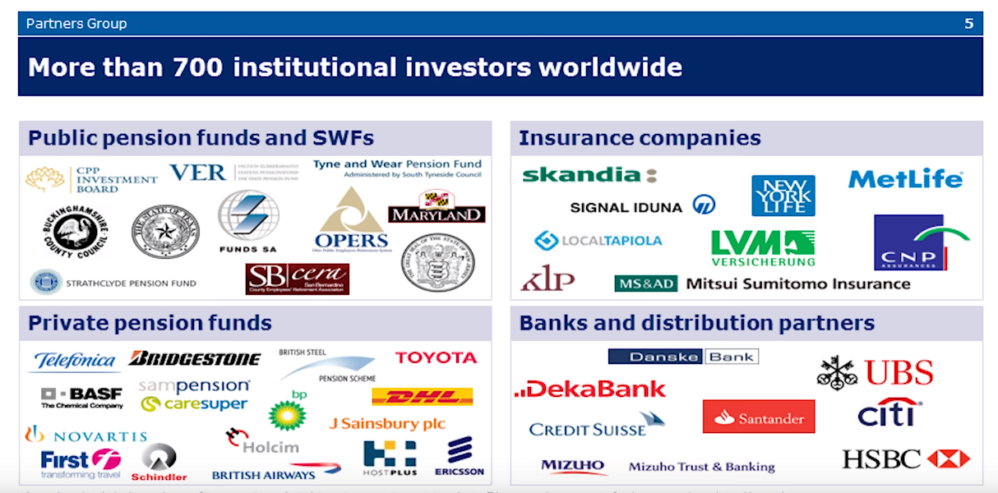

* More than 1,000 professionals across 19 offices worldwide. Risk Management team has 17 members globally, with 3 members in Singapore.

|  |  |  |  |  |
| --- | --- | --- | --- | --- |
|  | **Private Equity** | **Private debt** | **Private real estate** | **Private infrastructure** |
| **Guiding funding principles** | Acquire companies with strong management team and infrastructure;  Screen sub-segments of the market and focus on identifying category winners that are leaders in the sub-segment in terms of market share or growth potential;  Search for niche leaders with value creation potential and strong defensive characteristics | Focus on liquid, direct and subordinated loans from companies that have recession resilience, stable recurring cash flows and high cash conversion levels | Buy below replacement costs, i.e. target low valuation assets located in rebounding markets  Buy, fix and sell older buildings in prime locations  Target markets with strong long-term fundamentals and trends | Capitalize on platform expansion opportunities and focus on operational value creation |
| **Performance** | 23% IRR on fully realized buyout direct investments  Annualized outperformance over a cash flow equivalent MSCI world investment of 6% | 12.8% IRR on fully realized mezzanine direct investments  Annualized outperformance over a cash flow equivalent MSCI world investment of 3% | 16% IRR on direct real estate investments  Annualized outperformance over a cash flow equivalent MSCI world investment of 4% | 16% IRR on infrastructure and related investments  Cash yields ranging from 6% to 20% |

* Private Equity fundamentals
  + **Definition**: Specialized firm that establishes a fund to invest in private companies and/or start-ups, with the goal of helping them grow and selling them in future for profit (usually the exit period is about 3 – 7 years after original investment)
  + **Private equity is illiquid** – Unlike public equities, you cannot sell a private company overnight, thus there is a need to compensate investors for taking on this additional risk (i.e. idiosyncratic risk; increases with time). In other words, private equities should give investors extra returns above public equities
  + Reasons why PE firms/private equities outperform public equities:
    - Better access to inside information: Heavy due diligence would be carried out before investment in order to assess management’s future goals/plans
    - Control/Influence over invested private companies through board seats: May/May not reshuffle management, and provide advice to operations, strategy and financial management
    - Long term prospects: Goal is to help private companies to grow in the long run.
  + **Fee Structure**: Management fees (e.g. 2% per annum) + Performance fees (e.g. 20% on profits)
  + **Main groups**: Venture Capital (for start-ups; high risks), Growth Capital (for established private companies looking for capital to expand into new markets without change in control of business) for and Leveraged Buyout or LBO (i.e. taking a public company private by buying out outstanding stocks, implementing change management and making it public again)

Regress asset returns (e.g. public equity) against market returns

* Idiosyncratic risk is not priced, systematic risk is priced

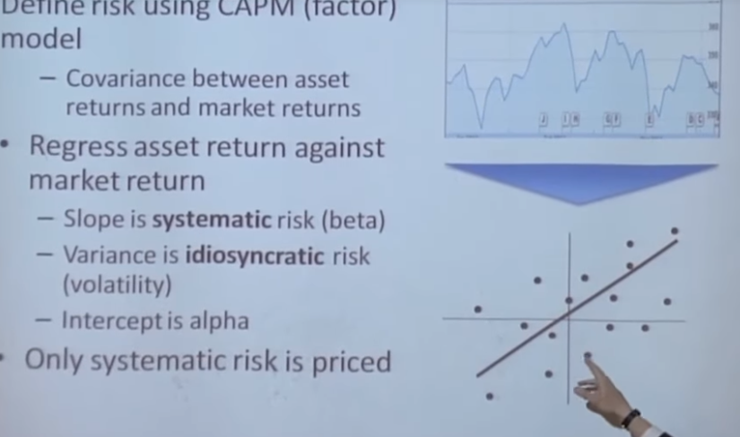

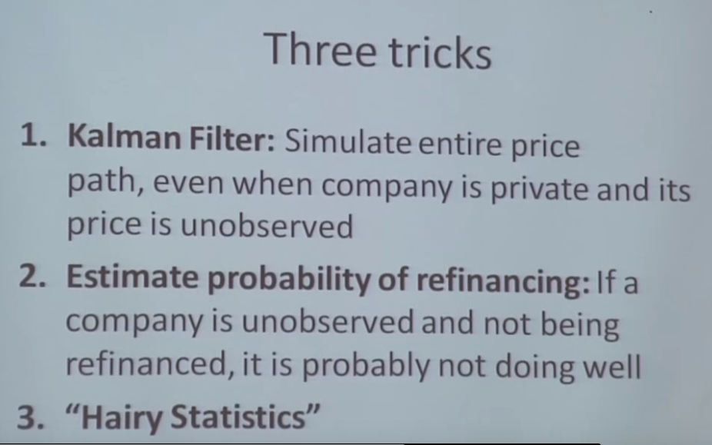

1. **Risk Management Team – Junior Risk Manager**

* Currency hedging: Support the firm’s multi-billion EUR currency hedging function, proposing trades and conducting ad-hoc analysis

**Why currency hedging is required?**

* + **Transaction Risk** – Currency volatility can have a favourable or unfavourable effect on the purchase and sale prices of PG’s assets
  + **Purchase Exposure and NAV** – By holding foreign assets in a fund, FX movements can have an impact on NAV
  + **Management fees and expenses** – Receiving management fees in a different currency to the base (recall that PE firms receive annual management fees, i.e. revenue)

**Outstanding issues affecting EUR:**

* Ongoing Greek crisis – multiple bailout package to avoid defaulting on obligations
* Trade tariffs between US and EU
* Fed rate hikes – may influence markets to invest heavily in USD for profits
* Deal allocation: Generate deal allocation analysis for investment committee submissions, ensuring an optimal and fair allocation for PG clients
* Quantitative modelling: Conduct performance analysis
  + Internal Rate of return – Discount rate at which NPV of all future cash flows = 0
  + Multiple of Money – Amount of money returned divided by the amount invested for that particular investment
  + Public Market Equivalent – Evaluates the performance against a public benchmark or index
* Special projects: Improve PG’s risk management processes
* Interest in international financial industry’s mechanisms
* Passion for numbers and quantitative analysis

1. **Interview questions**
2. ***Tell me more about yourself***

My bachelor’s degree was from NUS, where I majored in Accountancy. That was between 2009 and 2013.

Between 2013 and 2016, I was a manager with the Central Provident Fund (CPF) Board, where I was involved in:

* Analysing raw data to (1) ensure that they are accurate for government scheme payouts and (2) identify prevalent trends and provide relevant recommendations to support government policy reviews
* Working directly with my IT colleagues on special projects to design news systems and enhance existing ones

Thereafter in 2016, I went on to pursue my joint Master studies in Quantitative Finance with SMU and City University, which is based in London.

After my graduation from my Masters studies in Aug 2017, I took up a job with my current employer, Mizuho Bank, where my primary roles involves developing robust financial tools for various cross-department stakeholders (e.g. Treasury, Global Banking etc.) and overseas branches. A few months ago, I helped one of the overseas branches develop a tool that could measure the interest rate risk associated with their FX currency trading books automatically by first importing the swap rates and next calculating the basis point values (1 BPV/delta) for all outstanding FX transactions. The tool was developed using Excel VBA. Prior to the tool, the overseas branch had to import the rates and re-perform the delta calculations manually on the Excel spreadsheets. Besides the development role, I am also in charge of researching on latest Fintech developments and assessing how these solutions could be applied in the bank’s setting to improve operational performance.

**BPV**

*For the sake of simplicity we will use just one interest rate to discount the bond cash flows. That rate is 5.00%. Discounting the cash flows using this rate will give you a value for the 5 year bond of $10,000,000.*

*We will now repeat the exercise using an interest rate of 5.01%, (rates have increased by 0.01%). The bond now has a value of $9,995,671.72.*

*There is a difference of $4,328.28.*

*It shows that the 0.01% increase in interest rates has caused a fall in the value of the bond. If you held that bond you would have lost $4,328.28 on a mark-to-market basis.*

*This is the BPV of the bond. Traders can use BPV in order to adjust their exposure to interest rate risk. If a dealer expects interest rates to rise he will reduce the BPV of the portfolio. If he expects rates to fall the BPV will be increased.*

1. ***Workfare details***

Just a brief introduction on Workfare, which was the government scheme that I was working on. Workfare is a government scheme that encourages eligible lower wage workers to stay employed by supplementing their monthly incomes and retirement savings with monthly payouts. It also encourages them to up-skill by providing separate funding support for their training purposes.

Before 2017, one of the qualifying criteria is that the worker must be earning a gross monthly income of not more than $1,900.

During the Workfare policy review for 2017’s implementation, one of the goals was to ensure that Workfare will continue to be targeted at the bottom 30th income percentile of workers. From the income data residing in our database, we were able to identify that the nominal gross income of the bottom 30th percentile has increased from $1,900 in 2012 to $2,000 in 2015. Thus, we proposed to our Minister to peg the new income ceiling to $2,000 instead for 2017’s implementation.

1. ***Why do you want to pursue a risk analyst job at PG?***

Personally, I am someone who enjoys working in an environment where there are ample learning opportunities and work challenges. The PE risk management space presents itself as an ideal environment because the issue of risk remains relatively unexplored due to the specific characteristics of private equity investments. In other words, standard risk management tools that are used in other asset classes are unlikely to be applicable. Thus, if given the opportunity, I wish to build up my knowledge in PG’s private equity investments and make use of historical data to derive useful insights/analysis, which could in turn be used to improve quantitative risk models to optimize risk-reward/deal allocation.

1. ***Why Partners Group? Why from Bank to PE firm?***

My current job at the bank focuses more on the IT programming aspects, where I use programming languages to design financial tools to simplify/automate manual processes. At the end of the day, it is a stable job with stagnant growth opportunities. While I could opt to switch out of my current department so as to enhance my learning/growth opportunities, I feel that there are no other departments within the bank that would allow me to utilize my existing knowledge and skillsets to their fullest potential. This is largely because Mizuho Singapore branch, in comparison with its peers, is still in its infancy stage of adopting data analysis into their business decision-making framework.

PG is one of the largest private markets investment managers in the world with global private equity investments. This means that there are ample opportunities for me to utilize my existing knowledge and skillsets fully to understand these investments, derive insights and use the insights to improve quantitative risk models so as to optimize risk-reward/deal allocation.

1. ***Why do you want to leave your previous job at CPF Board? Why the sudden decision to further your studies? And why Quantitative Finance?***

First, I believe in the process of lifelong learning. Since knowledge and technology are changing with time, I feel that it is important to keep up with current environment by acquiring relevant skillsets that I did not have previously, such as programming.

Second, I always have an interest in financial data analysis. With the abundance of data in this time and age, there are ample opportunities where we can use them to derive useful insights to improve business processes and decision making. These 2 reasons propelled me to pursue a Master’s degree in Quantitative Finance.

1. ***What is the riskiest thing that you have done?***

The riskiest thing I have done was revising for my GMAT test 3 days prior to the test date. That was in 2016. Back then, I was busy rolling out a major time-critical project for CPF Board. There was hardly enough time for revision as I had to work occasionally on weekends. When I finally had the time for revision, I spent half a day designing a study plan and setting daily goals. The daily goals involved familiarizing myself with tonnes of vocabulary that I had not seen in my life and reviewing the sample GMAT papers. This was necessary for me as it had been 3 years since I left formal education and I did not receive any formal GMAT training prior to the test.

During those 3 days, I stuck closely to my study plan and ensured that the daily goals were met at the end of each day. While this was a risky move, I believed that my self-discipline and ability to cope with high pressure time-critical situations would see me through this difficult time. Because of these characteristics, I managed to pass the GMAT test.

1. ***What is your biggest mistake?***

During my stint with CPF Board, part of my job involved dealing with large amounts of data to ensure that they are accurate for government payouts. In that incident, I overlooked on some data anomalies and this resulted in erroneous payments made to the public. When I realized what I had done wrong, I immediately took responsibility and devised a recovery action plan to inform the affected individuals about the erroneous payments. As the affected number was less than 10, I called up each of them to apologize, and explained to them how the erroneous payments came about.

1. ***Describe one major time-critical project that you took part in and describe how you handled it?***

One of the major time-critical projects that I handled was during my current stint with Mizuho Bank, where I had to invent a new tool to automate the matching and booking of Non-Deliverable Forward (NDF) trades between front-end and back-end systems within the short time span of 2 weeks.

It was an intensive process because I had to work with inherent system constraints/differences and think of innovative ways to match and book the NDF trades accurately and automatically in both front and back office systems, without changing the existing front and back office system designs. In the end, I resolved all these issues with the use of Excel VBA and Robotic Process Automation (which was a new and untested technology for the Bank). As a result of this automation tool, a total of 2 man-hours was saved on a daily basis for both front and back offices.

1. ***Do you have any questions for us?***

* What is the career progression like?
* What are the performance expectations of this position over the first 6 months?